2016 Eagles JV Baseball
Day | Date | Opponent | Location | Time
Monday | 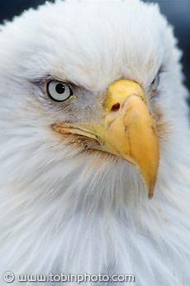  March 14 | Clinton | Gibbs | 5:00
Tuesday | March 15 | Clinton | Gibbs | 3:00
Wednesday | March 16 | Anderson Co | Gibbs | 5:00
Thursday | March 17 | Anderson Co | Anderson Co | 5:00
Monday | March 21 | Powell | Powell | 7:30
Tuesday | March 22 | Powell | Gibbs | 5:00
Monday | March 28 | Oak Ridge | Gibbs | 5:30
Tuesday | March 29 | Oak Ridge | Oak Ridge | 7:30
Wednesday | March 30 | Central | Gibbs | 5:00
Thursday | March 31 | Danville KY | Gibbs | 4:00
Monday | April 4 | Halls | Gibbs | 5:00
Tuesday | April 5 | Halls | Halls | 7:30
Monday | April 11 | Karns | Gibbs | 5:00
Tuesday | April 12 | Karns | Karns | 5:00
Thursday | April 14 | Heritage | Gibbs | 6:00
Wednesday | April 20 | Central | Shumpert Park | 5:00
Monday | April 25 | Campbell Co | Gibbs | 5:00
Tuesday  Thursday | April 26  April 28 | Campbell Co  Heritage | Campbell Co  Heritage | 7:30  6:00

